**Title of the project**

**Building Data Model and Writing ETL Job**

* **Extract the data from any preferred location – for this project we have extracted data from the below link:**

<https://www.postgresqltutorial.com/postgresql-getting-started/postgresql-sample-database/>

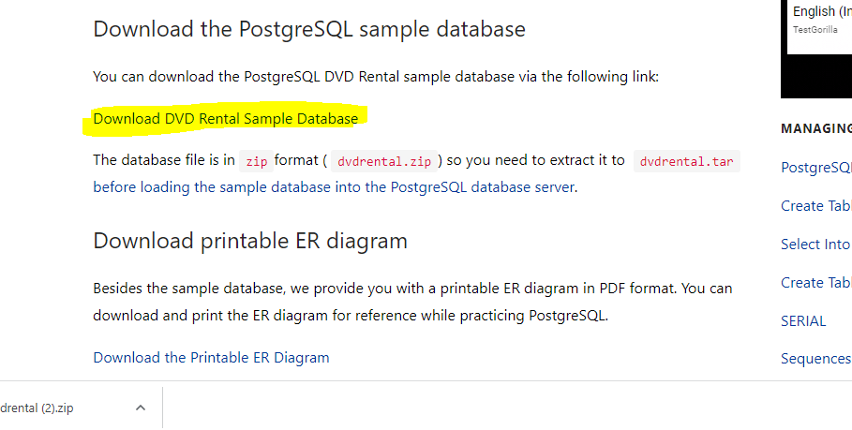

* Click on download DVD Rental Sample Database.
* Open pgAdmin and click on database – Create (to create a new database)
* Now create a new database with the name “dvdRental”.

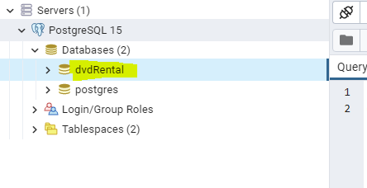

* To load the data into the database -> right click on dvdRental -> and select the option restore.

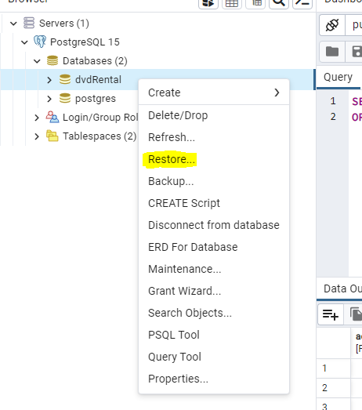

* Click on Restore and provide the file path.
* Click on refresh.
* Now go to schemas and click on tables.

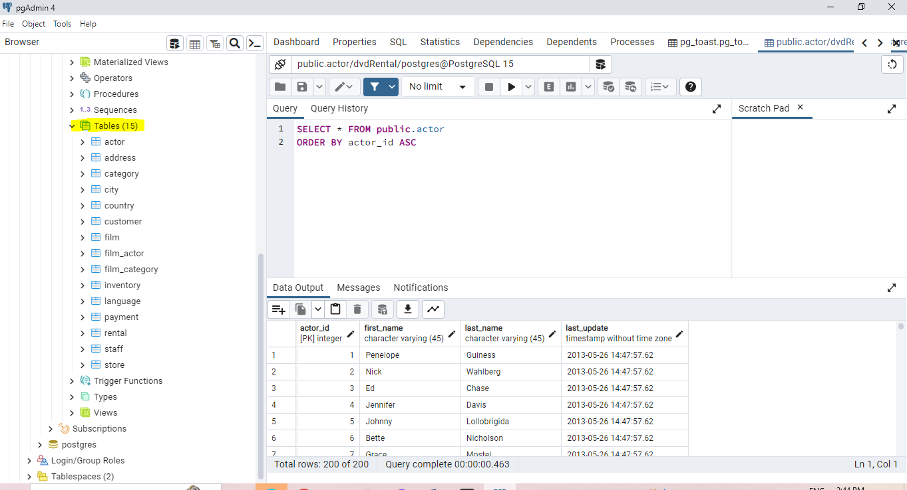

* To view the data in the table, click on -> view/edit data.

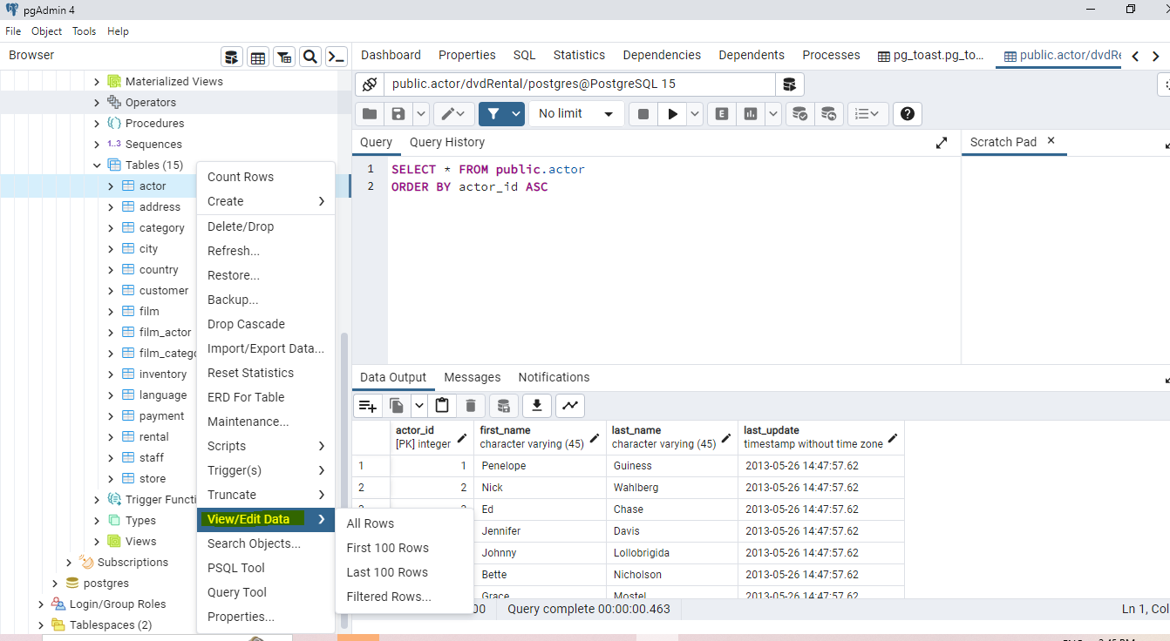

* The schema design of dvdRental is as shown below:

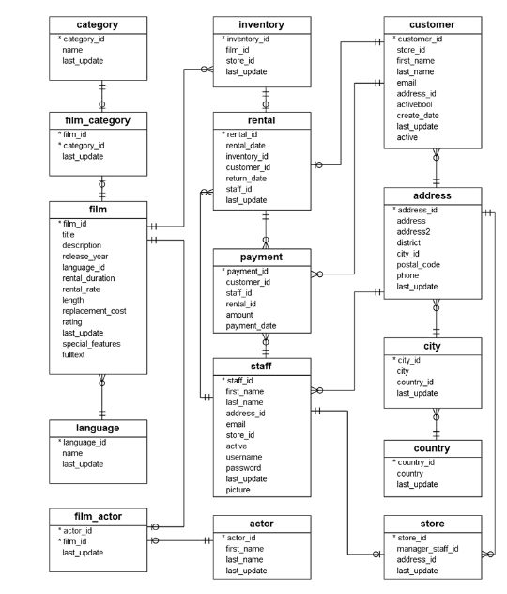

* In the above ER diagram, we have different-different tables connected based on primary key and foreign key.
* To view the tables go to pgAdmin -> click on tables -> Query Tool.

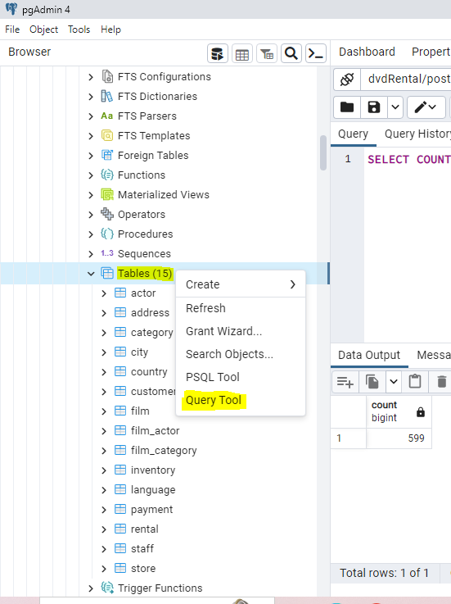

* To get the count of the columns in the customer table we can use the below query.

SELECT COUNT(*) FROM customer;

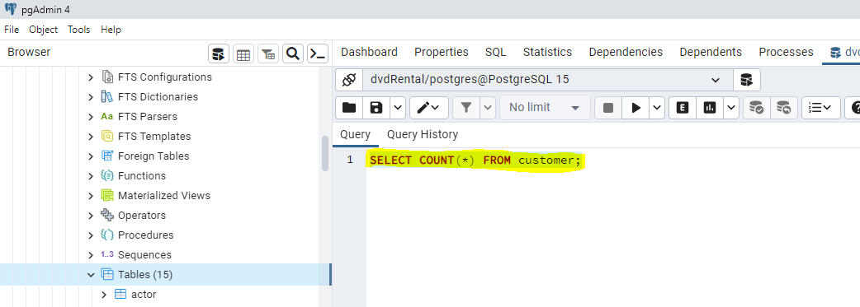

* Click on RUN to see the output (count of columns present in the customer table).

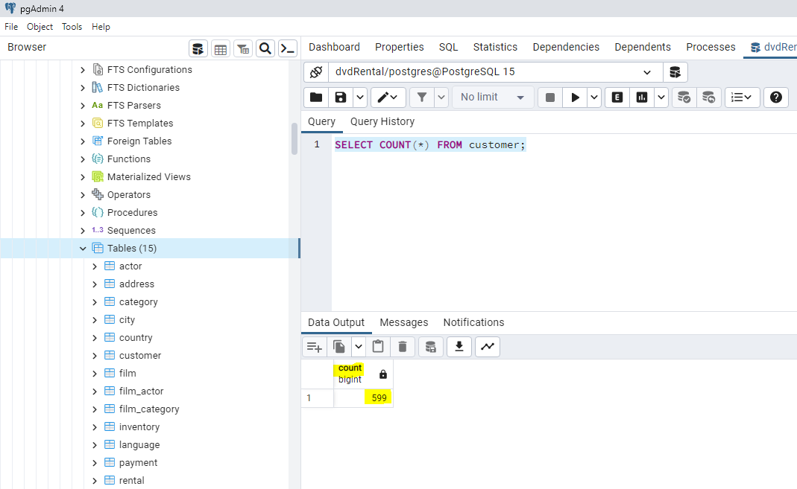

* To select the min and max date for the payment use the below command.

SELECT min(payment_date) min_payment,

max(payment_date) max_payment FROM payment;

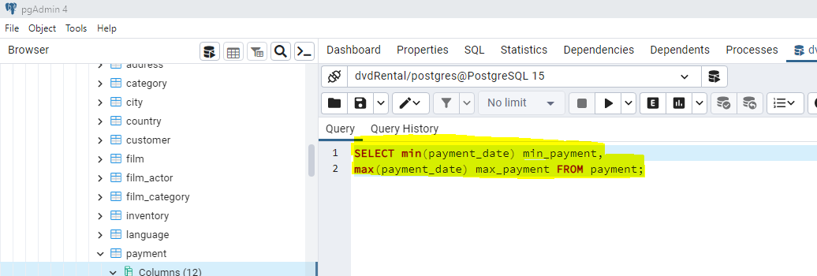

* Click on RUN command to see the below output.

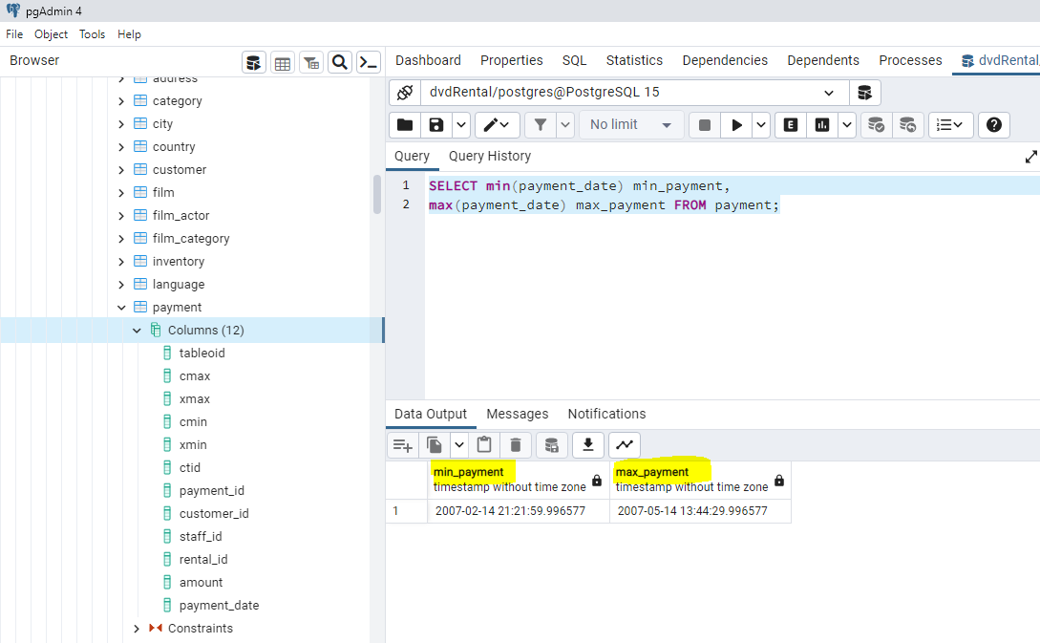

* If we want to get the payment information from the film section then we have to join both the tables however as we see that there is no common connection between the tables we have to connect the tables with the help of multiple joins as shown below.
* First join payment table and rental table on rental_id using the below code.

SELECT p.payment_id, p.rental_id, p.amount, r.inventory_id from payment as p

join rental r ON p.rental_id = r.rental_id;

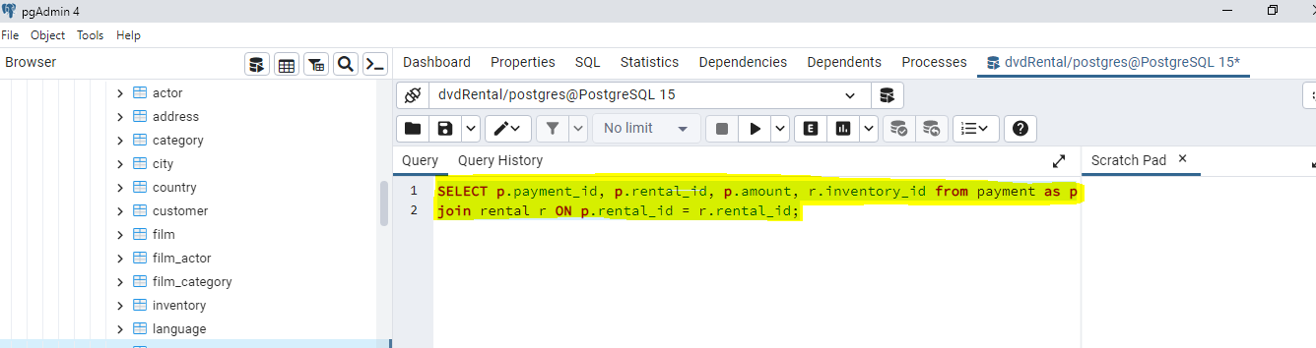

* Run the command to get the below output.

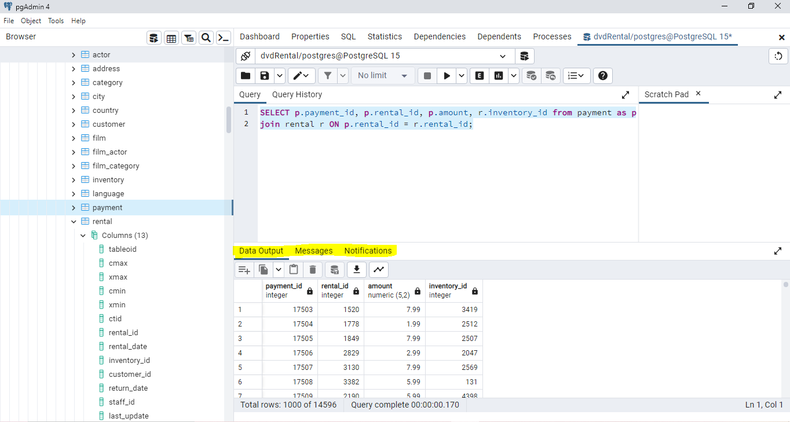

* Next, we need to join rental table with inventory table on inventory_id using the below code:

SELECT p.payment_id, p.rental_id, p.amount, r.inventory_id, i.film_id from payment as p

join rental r ON p.rental_id = r.rental_id

join inventory i on i.inventory_id = r.inventory_id;

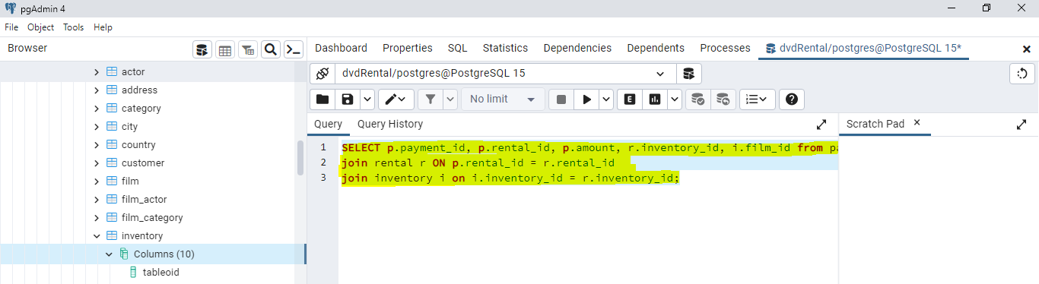

* Run the command to get the below output:

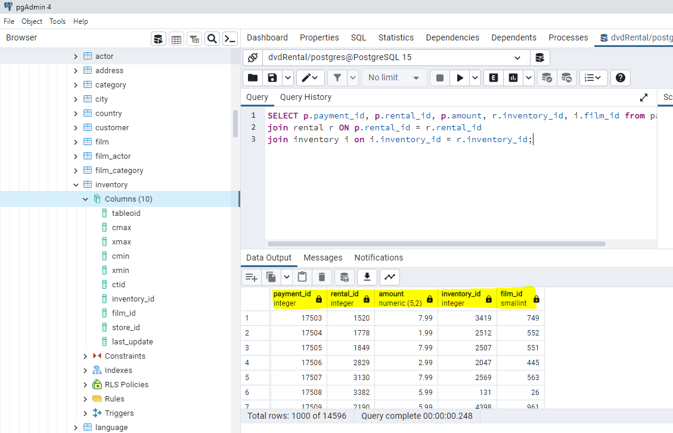

* Next join the inventory table and the film table on film_id using the below code:

SELECT p.payment_id, p.rental_id, p.amount, r.inventory_id, i.film_id, f.title from payment as p

join rental r ON p.rental_id = r.rental_id

join inventory i on i.inventory_id = r.inventory_id

join film f on f.film_id = i.film_id;

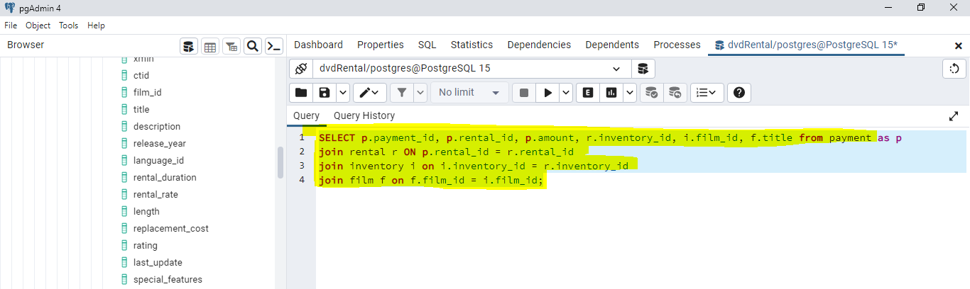

* Click on run command to get the below output.

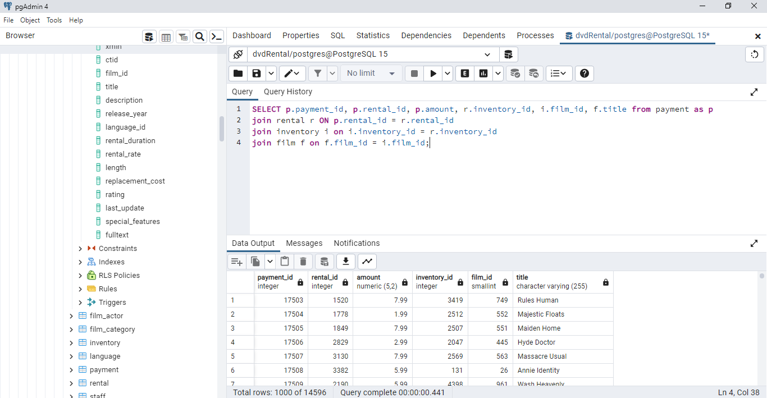

* Finally, we have the payment information on all the films

Ex: the film with title -> Hyde doctor has made a payment of 17506.

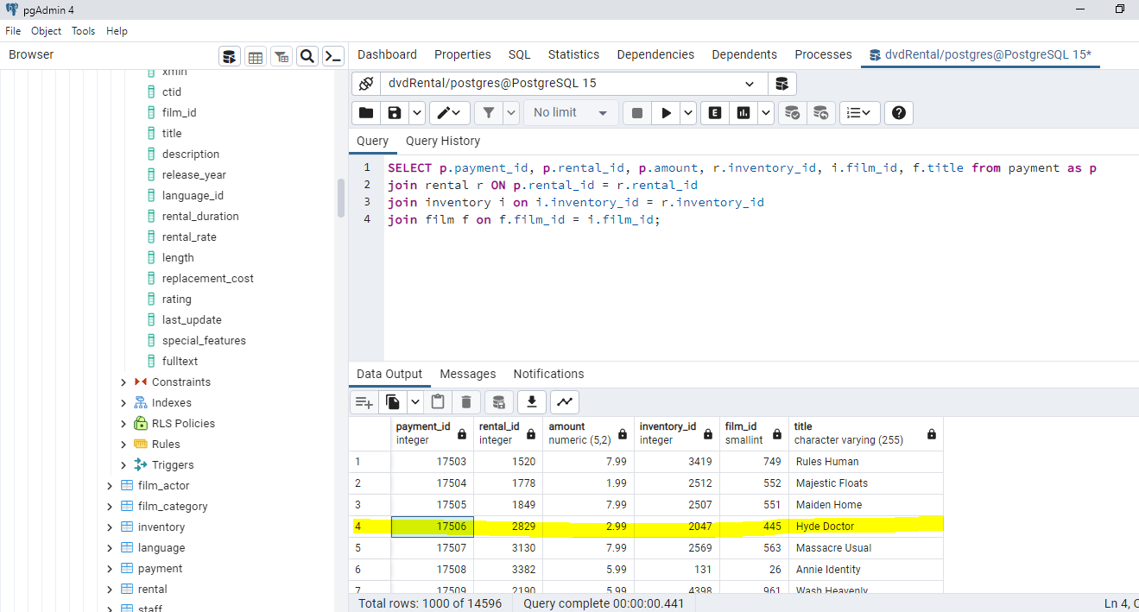

* To know how much amount does the film make use the below code:

SELECT f.title,SUM(p.amount) AS revenue from payment as p

JOIN rental r ON p.rental_id = r.rental_id

JOIN inventory i on i.inventory_id = r.inventory_id

JOIN film f on f.film_id = i.film_id

GROUP BY f.title;

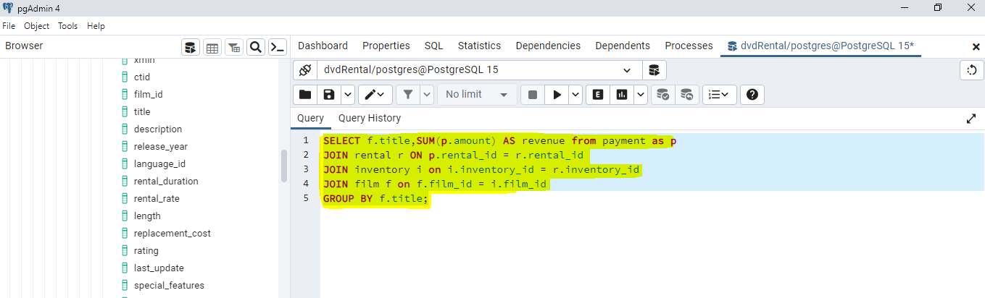

* Run the command to get the below output.

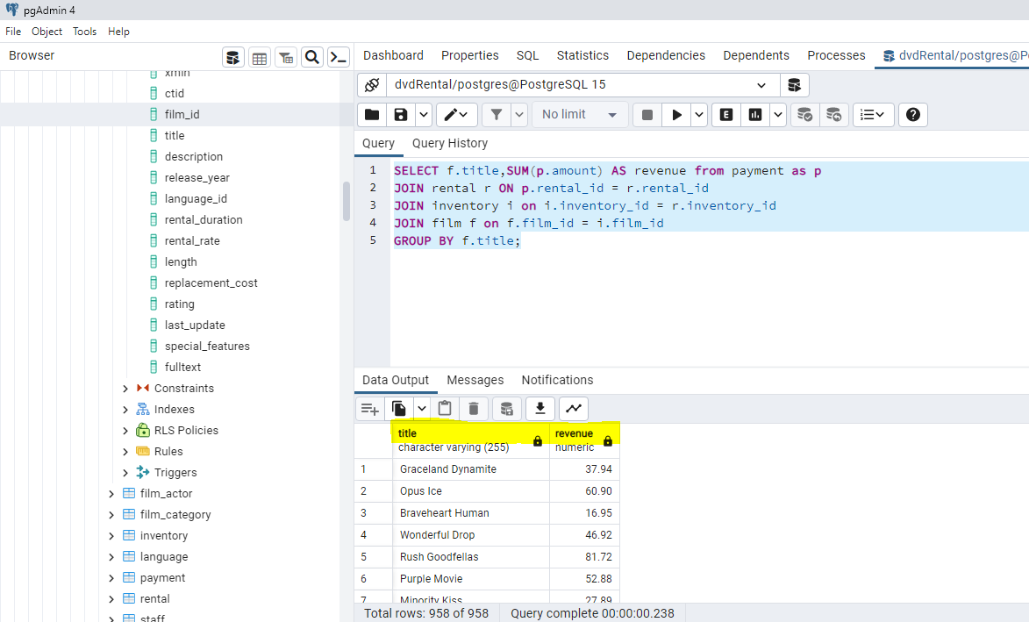

* To get the maximum of the revenue use the below code:

SELECT f.title,SUM(p.amount) AS revenue from payment as p

JOIN rental r ON p.rental_id = r.rental_id

JOIN inventory i on i.inventory_id = r.inventory_id

JOIN film f on f.film_id = i.film_id

GROUP BY f.title

ORDER BY SUM(p.amount) DESC;

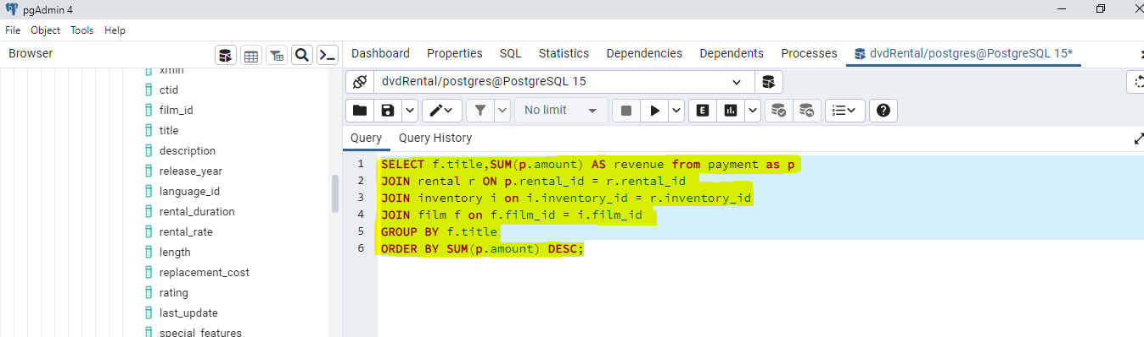

* Run the command to get the below output.

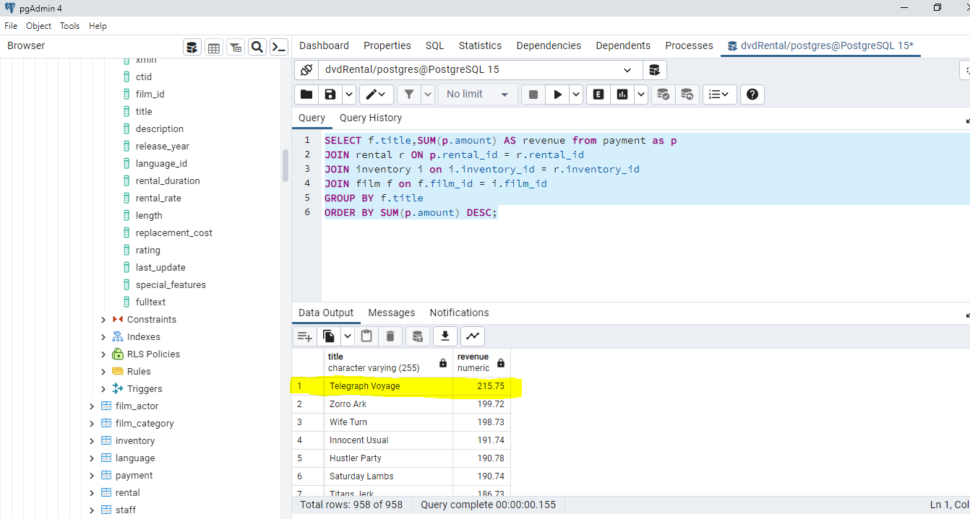

* To get the minimum revenue use the below code.

SELECT f.title,SUM(p.amount) AS revenue from payment as p

JOIN rental r ON p.rental_id = r.rental_id

JOIN inventory i on i.inventory_id = r.inventory_id

JOIN film f on f.film_id = i.film_id

GROUP BY f.title

ORDER BY SUM(p.amount) ASC;

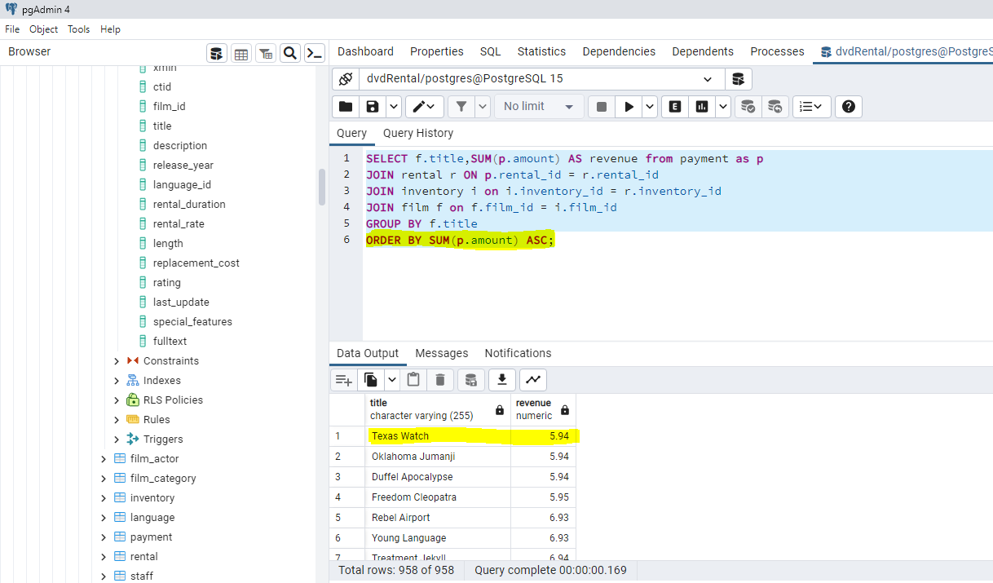

* To find highest revenue generated by city we need to join payment table and city table however there is no direct connection between both the tables so first we have to join payment table and customer table then need to join address and finally join city table to get the desired output.
* Use the below code to get the output.

SELECT p.payment_id, p.customer_id, cu.address_id, a.city_id, c.city from payment as p

JOIN customer cu ON cu.customer_id = p.customer_id

JOIN address a ON a.address_id = cu.address_id

JOIN city c ON c.city_id = a.city_id;

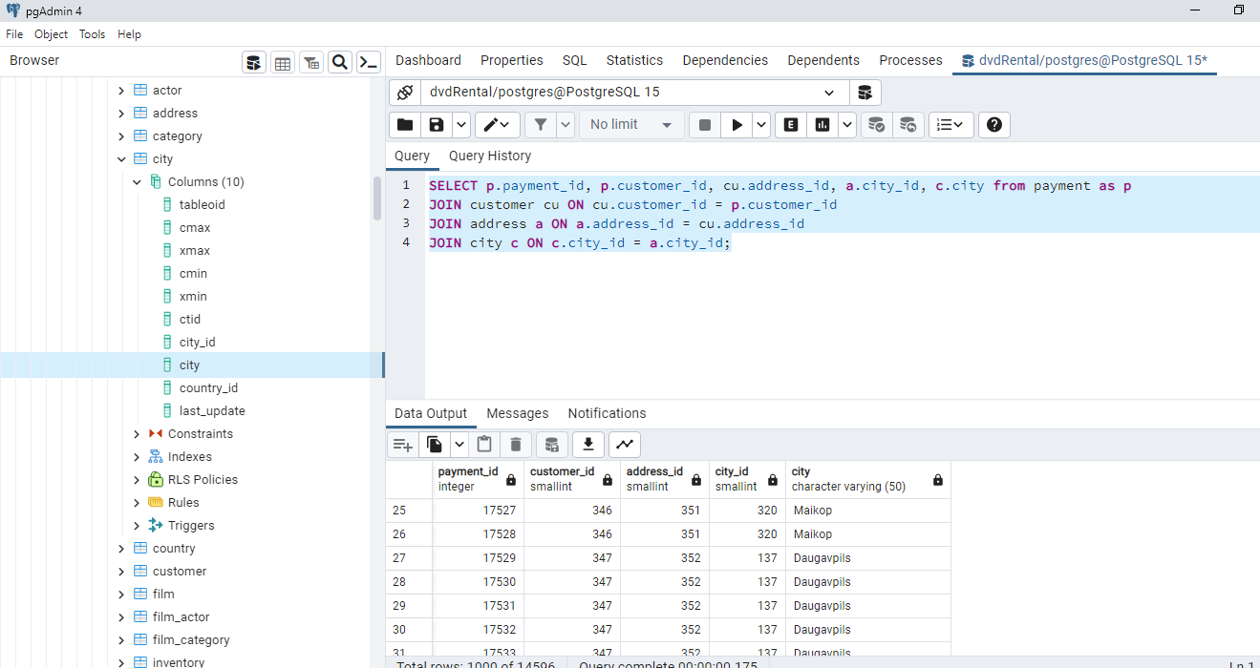

* Now to see the revenue base on city use the below code:

SELECT c.city, SUM(amount) AS revenue from payment as p

JOIN customer cu ON cu.customer_id = p.customer_id

JOIN address a ON a.address_id = cu.address_id

JOIN city c ON c.city_id = a.city_id

GROUP BY c.city;

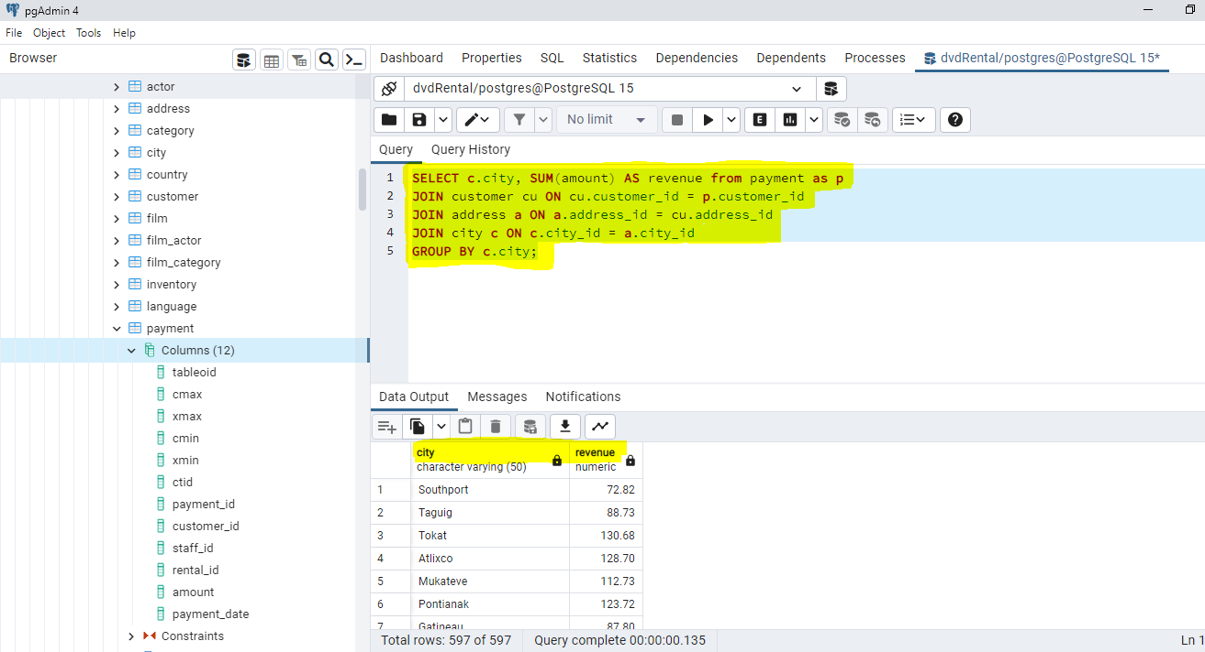

* To get the highest revenue based on city use the below code.

SELECT c.city, SUM(amount) AS revenue from payment as p

JOIN customer cu ON cu.customer_id = p.customer_id

JOIN address a ON a.address_id = cu.address_id

JOIN city c ON c.city_id = a.city_id

GROUP BY c.city

ORDER BY SUM(amount) DESC;

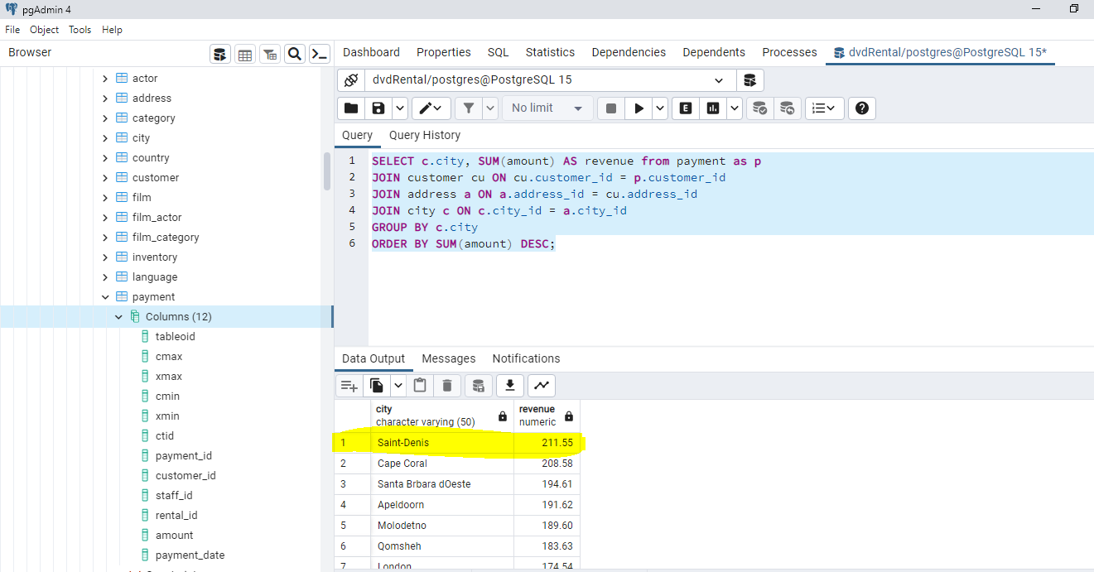

* If we see the 3NF schema we can say that data is redundant across different table and in order to avoid redundancy in the data we can convert the 3NF schema to star schema where repetitive data is stored in one dimension.
* The ER diagram for star schema is shown below:

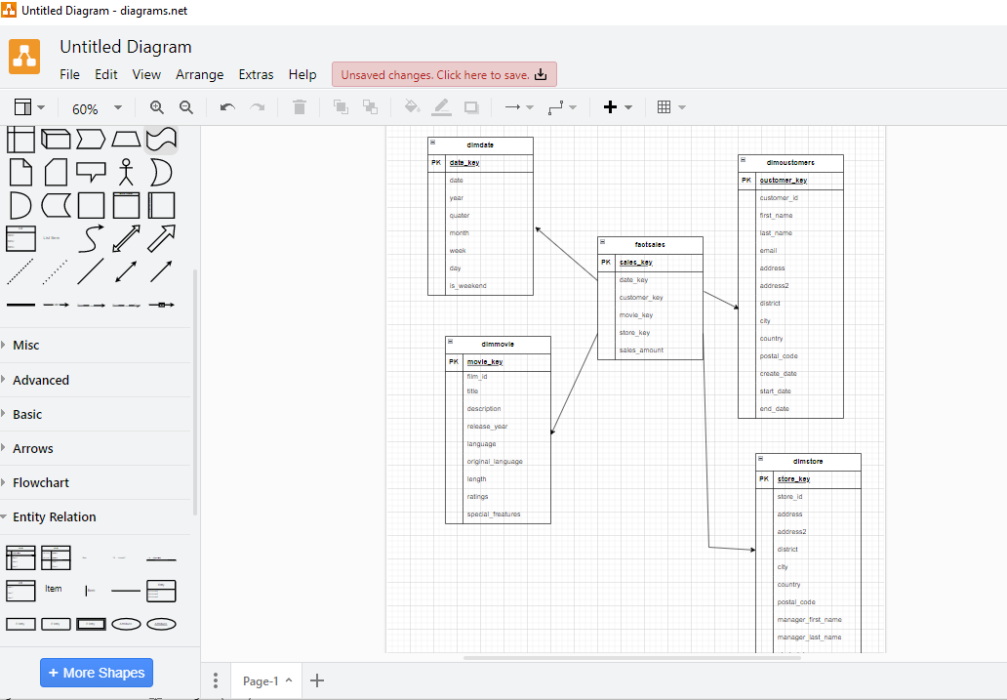

* By using the star schema, we have combined tables containing the same information.
* To create the same table in postgresql go to pgAdmin -> click on Query tool.
* Use the below code to create the dimdate table.

CREATE TABLE dimDate

(

date_key integer NOT NULL PRIMARY KEY,

date date NOT NULL,

year smallint NOT NULL,

quarter smallint NOT NULL,

month smallint NOT NULL,

day smallint NOT NULL,

week smallint NOT NULL,

is_weekend boolean

);

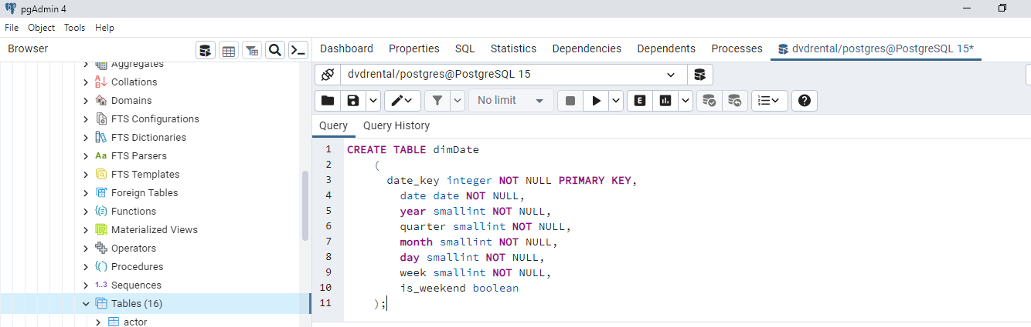

* Run the code to create the table.

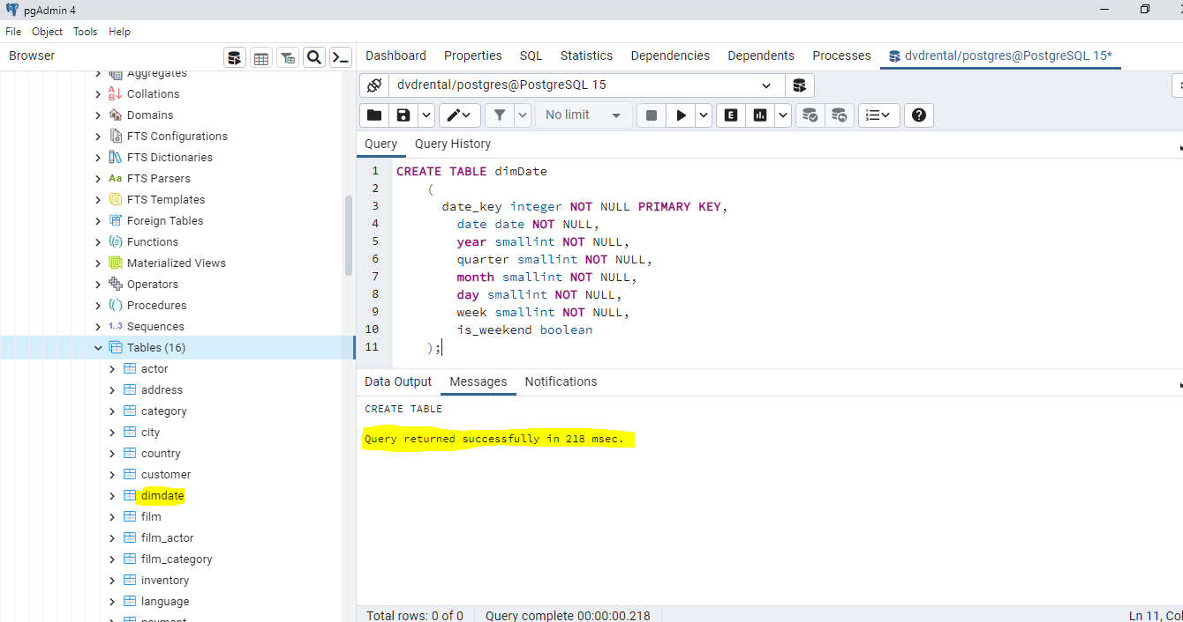

* Insert the data into the “dimdate” table and to do so we have to extract the information from the payment table.
* Use the below commands to insert the data:

INSERT INTO dimDate (date_key, date, year, quarter, month, day, week, is_weekend)

SELECT DISTINCT(TO_CHAR(payment_date :: DATE, 'yyyyMMDD')::integer) AS date_key,

date(payment_date) AS date,

EXTRACT(year FROM payment_date) AS year,

EXTRACT(quarter FROM payment_date) AS quarter,

EXTRACT(month FROM payment_date) AS month,

EXTRACT(day FROM payment_date) AS day,

EXTRACT(week FROM payment_date) AS week,

CASE WHEN EXTRACT(ISODOW FROM payment_date) IN (6, 7) THEN true ELSE false END AS is_weekend

FROM payment;

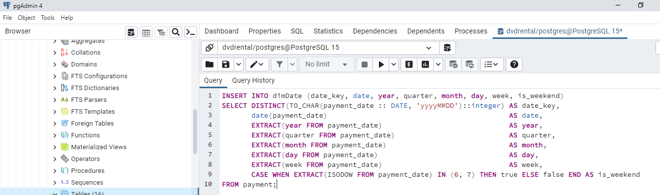

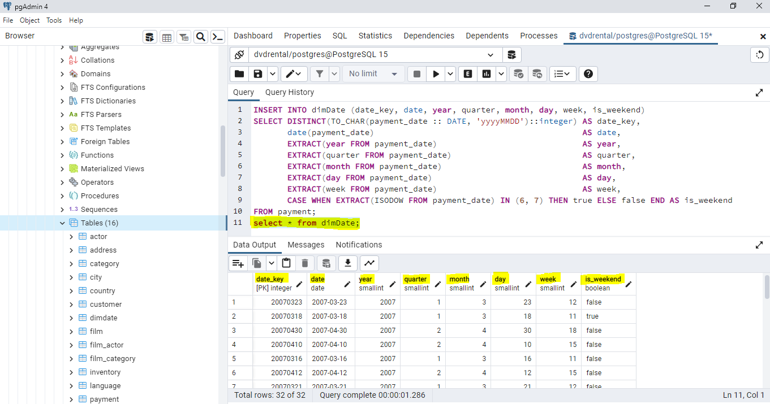

* Similarly use the below code to create “dimCustomer” table:

DROP TABLE IF EXISTS dimCustomer;

CREATE TABLE dimCustomer

(

customer_key SERIAL PRIMARY KEY,

customer_id smallint NOT NULL,

first_name varchar(45) NOT NULL,

last_name varchar(45) NOT NULL,

email varchar(50),

address varchar(50) NOT NULL,

address2 varchar(50),

district varchar(20) NOT NULL,

city varchar(50) NOT NULL,

country varchar(50) NOT NULL,

postal_code varchar(10),

phone varchar(20) NOT NULL,

active smallint NOT NULL,

create_date timestamp NOT NULL,

start_date date NOT NULL,

end_date date NOT NULL

);

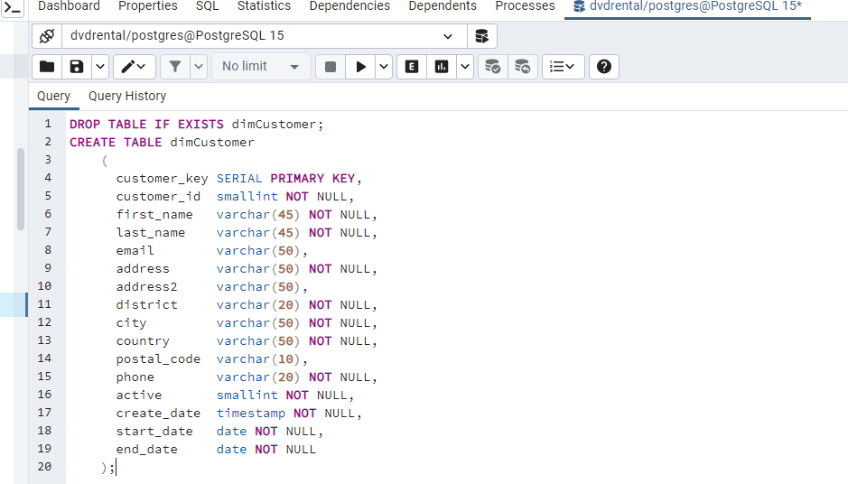

* Run the command to get the table.

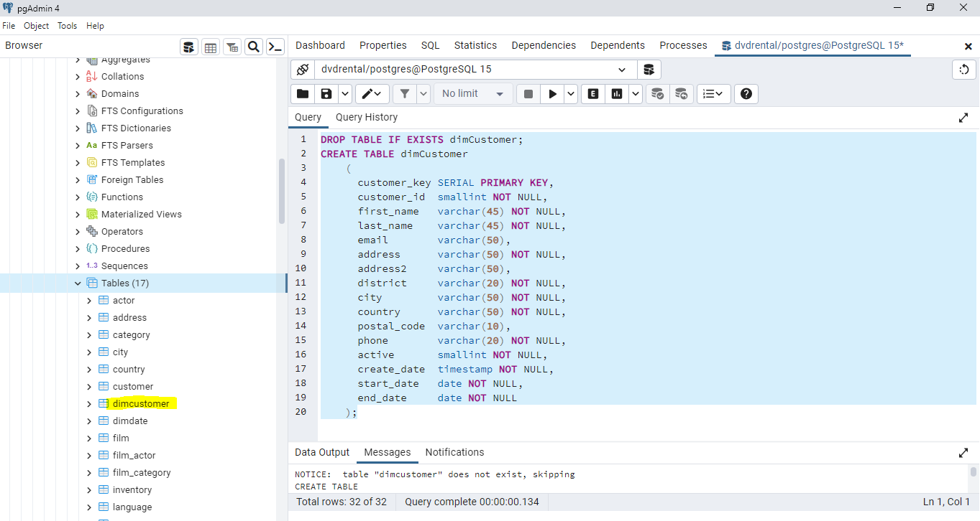

* Insert the data into the “dimCustomer” table using the below code:

INSERT INTO dimCustomer (customer_key, customer_id, first_name, last_name, email, address,

address2, district, city, country, postal_code, phone, active,

create_date, start_date, end_date)

SELECT c.customer_id as customer_key,

c.customer_id,

c.first_name,

c.last_name,

c.email,

a.address,

a.address2,

a.district,

ci.city,

co.country,

postal_code,

a.phone,

c.active,

c.create_date,

now() AS start_date,

now() AS end_date

FROM customer c

JOIN address a ON (c.address_id = a.address_id)

JOIN city ci ON (a.city_id = ci.city_id)

JOIN country co ON (ci.country_id = co.country_id);

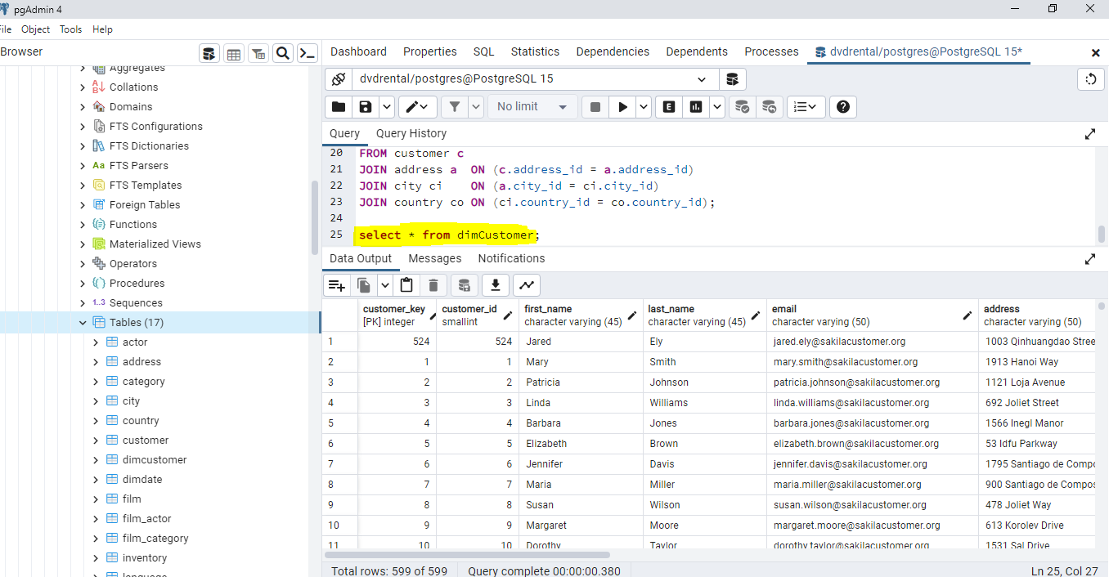

* Simillarly use the below code to create “dimStore” table:

CREATE TABLE dimStore

(

store_key SERIAL PRIMARY KEY,

store_id smallint NOT NULL,

address varchar(50) NOT NULL,

address2 varchar(50),

district varchar(20) NOT NULL,

city varchar(50) NOT NULL,

country varchar(50) NOT NULL,

postal_code varchar(10),

manager_first_name varchar(45) NOT NULL,

manager_last_name varchar(45) NOT NULL,

start_date date NOT NULL,

end_date date NOT NULL

);

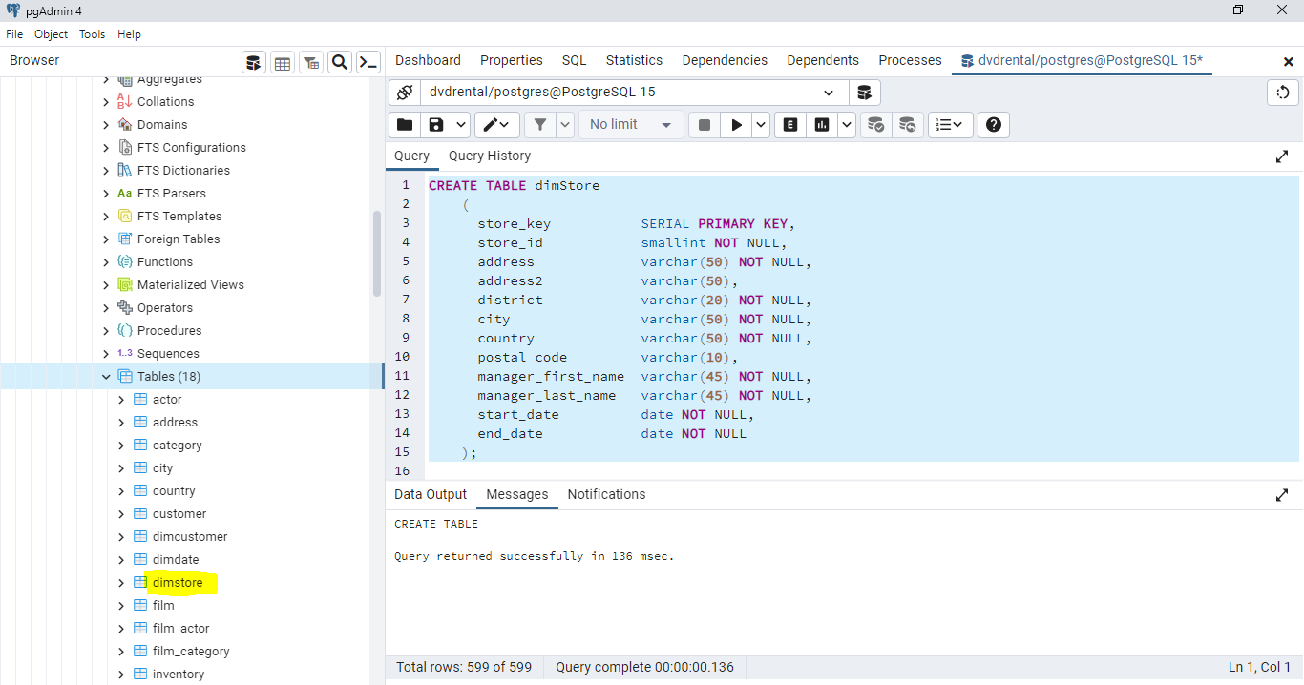

* Use the below code to insert the data:

INSERT INTO dimStore (store_key, store_id, address, address2, district, city, country, postal_code, manager_first_name, manager_last_name, start_date, end_date)

SELECT

s.store_id as store_key,

s.store_id,

a.address,

a.address2,

a.district,

c.city,

co.country,

a.postal_code,

st.first_name as manager_first_name,

st.last_name as manager_last_name,

now() as start_date,

now() as end_date

FROM store s

JOIN staff st ON (s.manager_staff_id = st.staff_id)

JOIN address a ON (s.address_id = a.address_id)

JOIN city c ON (a.city_id = c.city_id)

JOIN country co ON (c.country_id = co.country_id);

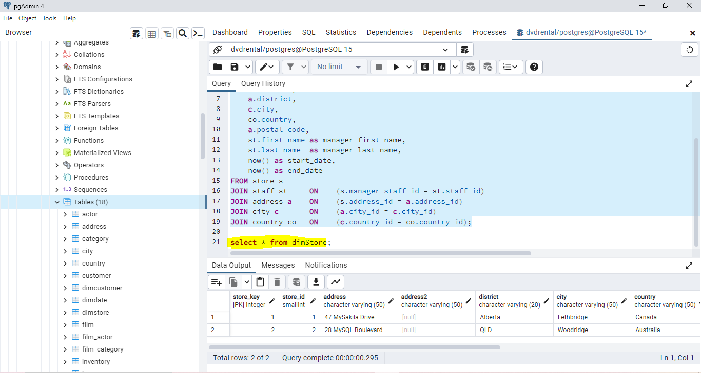

* Use the below code to create “dimMovie” table:

CREATE TABLE dimMovie

(

movie_key SERIAL PRIMARY KEY,

film_id smallint NOT NULL,

title varchar(255) NOT NULL,

description text,

release_year year,

language varchar(20) NOT NULL,

original_language varchar(20),

rental_duration smallint NOT NULL,

length smallint NOT NULL,

rating varchar(5) NOT NULL,

special_features varchar(60) NOT NULL

);

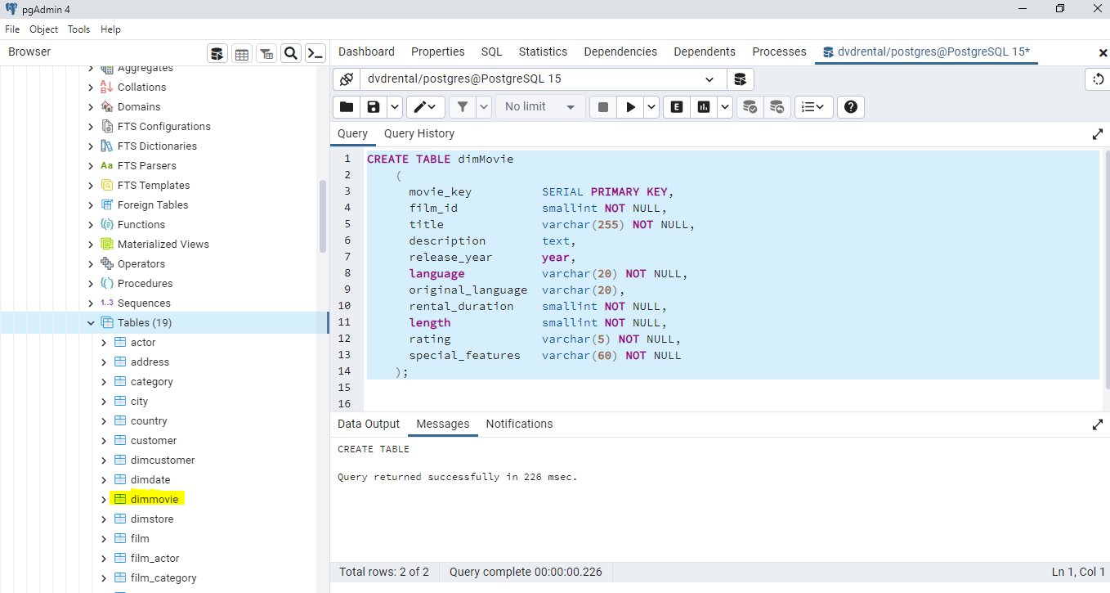

* Use the below code to insert the data:

INSERT INTO dimMovie (movie_key, film_id, title, description, release_year, language, original_language, rental_duration, length, rating, special_features)

SELECT

f.film_id as movie_key,

f.film_id,

f.title,

f.description,

f.release_year,

l.name as language,

orig_lang.name AS original_language,

f.rental_duration,

f.length,

f.rating,

f.special_features

FROM film f

JOIN language l ON (f.language_id=l.language_id)

LEFT JOIN language orig_lang ON (f.language_id = orig_lang.language_id);

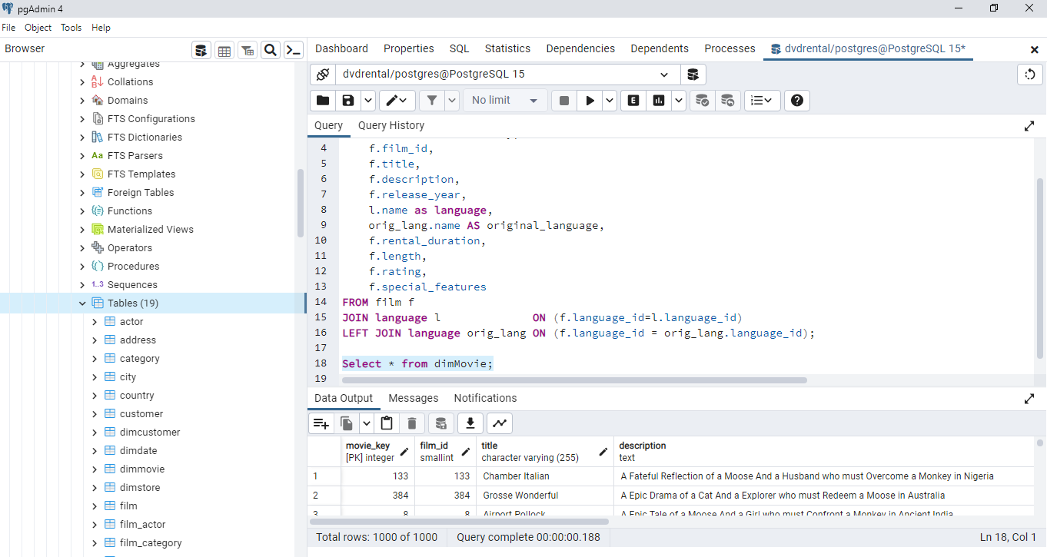

* Finally use the below code to create fact table:

DROP TABLE IF EXISTS factSales;

CREATE TABLE factSales

(

sales_key SERIAL PRIMARY KEY,

date_key integer REFERENCES dimDate (date_key),

customer_key integer REFERENCES dimCustomer (customer_key),

movie_key integer REFERENCES dimMovie (movie_key),

store_key integer REFERENCES dimStore (store_key),

sales_amount numeric

);

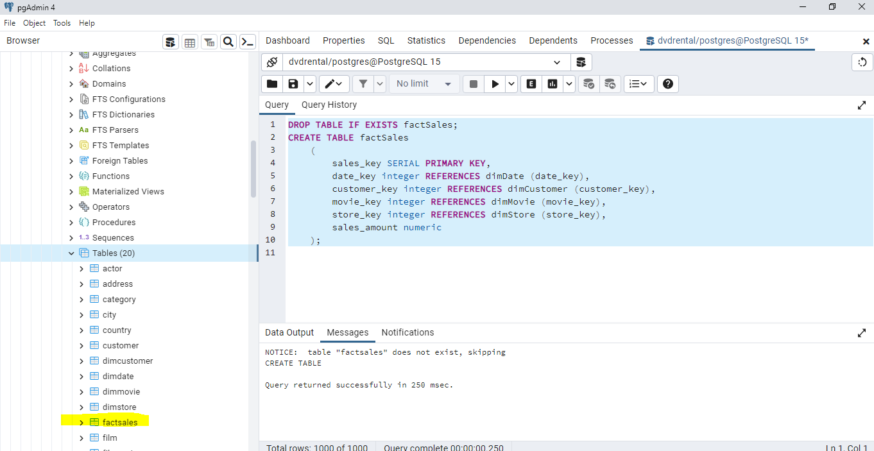

* Use the below code to insert the data in fact table:

INSERT INTO factSales (date_key, customer_key, movie_key, store_key, sales_amount)

SELECT

TO_CHAR(payment_date :: DATE, 'yyyyMMDD')::integer AS date_key,

p.customer_id as customer_key,

i.film_id as movie_key,

i.store_id as store_key,

p.amount as sales_amount

FROM payment p

JOIN rental r ON (p.rental_id = r.rental_id)

JOIN inventory i ON (r.inventory_id = i.inventory_id);

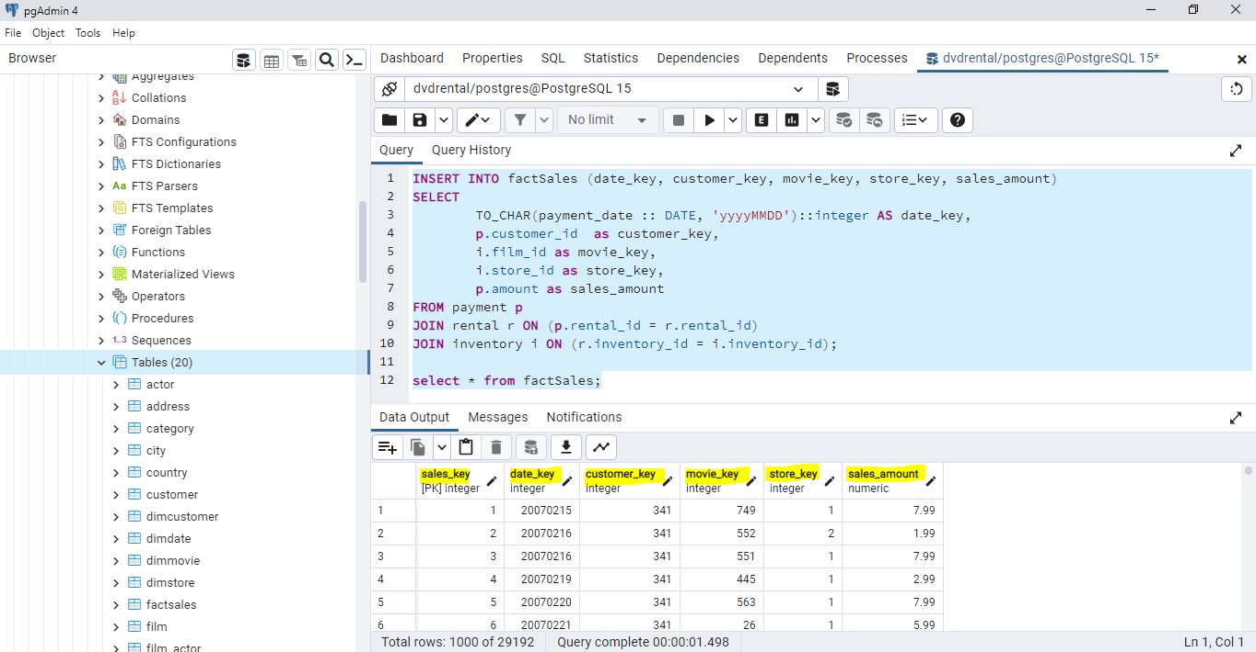

* To do analysis on the star schema it takes less time compared to 3nf schema as to achieve the desired analysis we have to join multiple table in 3nf schema which makes it complex where as in star schema it can be achieved with less joins which ultimately results in less complexity and less execution time.
* Star schema - It took 436 milliseconds.

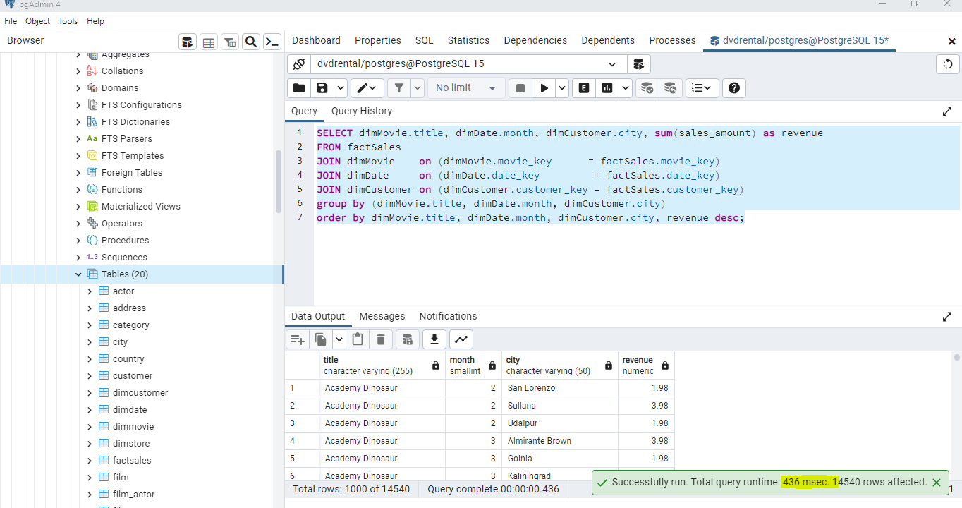

* 3nf Schema – It took 484 milliseconds:

